MAY 2025
Subject: Mental Health Awareness


May is Mental Health Awareness Month and at TGNA, the emotional health of all our employees and their families is a top priority. As part of the #TGhealthyME wellness program, please remember that you have access to valuable resources that can support your emotional well-being!

 | Virtual Therapy with Talkspace  Talkspace is a digital resource that can help with a wide array of emotional health concerns. You can message, talk to or video chat with a licensed professional who can help you pinpoint areas of concern and provide helpful strategies to feel better. Any associated costs are processed through insurance. Learn more at talkspace.com/connect.
 | Optum’s Employee Assistance Program (EAP)  The EAP is your resource when you or a family member is experiencing stress, anxiety or any other difficulty. Experienced counselors are available 24/7 to support you. Whether you need “in the moment” help or connections to longer-term solutions, you’ll get assistance from licensed, Masters-level counselors – and it’s all free and totally confidential. To learn more, visit liveandworkwell.com and enter TGNA as your access code, or call 800-622-7276.
  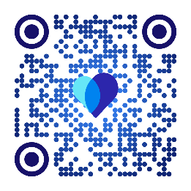 | Have Benefits Questions? Start with the Heart!  Need help finding benefits resources but aren’t sure where to start? Transcarent provides virtual access to care, benefits navigation, clinical guidance, care delivery and more! Scan the QR code to download the Transcarent app, visit member.transcarent.com or call 888-994-8481.
Want More Details About Your TG Benefits?
Visit our benefits website, tggroupbenefits.com (password: TGNA; location: United States).
There, you’ll find helpful information about all your benefits.

